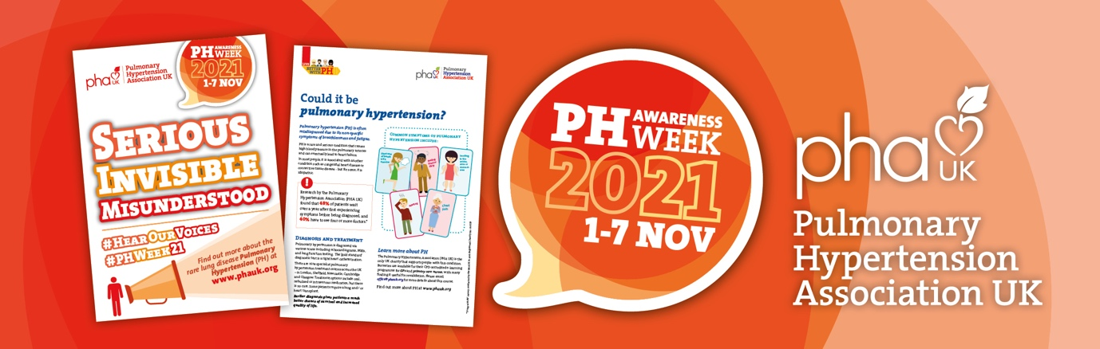

<The name and address of your practice>
<Date>

<Your name and address>

Dear Practice Manager,
I am a patient registered with your practice and I live with / care for someone who lives with <delete as appropriate> a rare disease called pulmonary hypertension (PH).
PH Awareness Week takes place in the UK during the first week of November and I am writing to ask if you will support this initiative by displaying the enclosed poster in your waiting room and circulating the enclosed information sheet around your medical team.
PH is very serious, often misunderstood, and often misdiagnosed. Research by the charity the Pulmonary Hypertension Association (PHA UK) found that 48% of patients wait over a year after first experiencing symptoms before being diagnosed, and 40% have to see four or more doctors.*
<Enter further information here, if you wish, about your own diagnosis>
It is vitally important that more primary care practitioners are aware of this devastating condition so that treatment can be started early and quality and longevity of life for patients improved.
If you would like further copies of the poster and / or information sheet, or digital versions that can be circulated via email, please contact the PHA UK on 01709 761450 or at office@phauk.org.
Thank you for taking the time to read this and I do hope you are able to support the awareness week in this small but important way.
Yours faithfully,
<Your name>

*’Living with PH’ survey, conducted by the PHA UK in 2016

