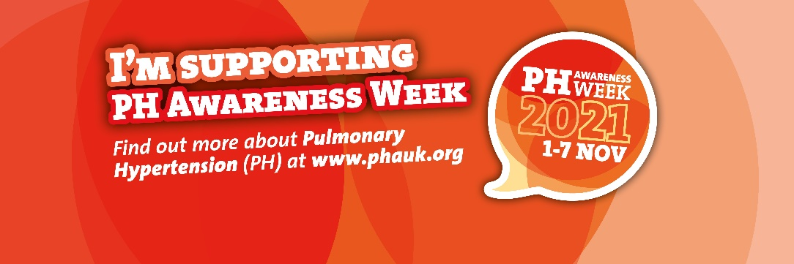

Dear (name)

Sharing my story for Pulmonary Hypertension Awareness Week,
November 1st - 7th 2021

I live in (name of town) and I’m writing to you to offer to share my experiences of living with pulmonary hypertension (PH) - a rare, life-limiting condition that causes high blood pressure in the blood vessels connecting the heart and lungs. There is no cure, and some people require heart and / or lung transplants.
Having PH affects me in the following ways: (Please describe how it makes you feel physically and emotionally, and any effect it has had on work / education / family life / getting around. You might also want to talk about the medication you are on).
PH Awareness Week, organised by the national charity the Pulmonary Hypertension Association (PHA UK), runs from November 1st - 7th 2021.
More people need to know about this rare condition, which is why I would like to share my story.
If you would like to speak to me as someone local living with PH, you can contact me on (telephone number and / or email address)
To speak to someone from the PHA UK, please email media@phauk.org.
You can find out more about the condition via their website, www.phauk.org.

Kind regards,
(name and postcode)

